

Request for Quotations

PROCUREMENT OF OFFICE FURNITURE
FOR CCAR-OSU

Country: | Pakistan
Project Name: | Strengthening Institutions for Refugees Administration (SIRA)
Implementing Agency: | Chief Commissionerate for Afghan Refugees (CCAR), Ministry of SAFRON
Grant No: | D5640-PK
Project ID No: | P165542
RFQ/ STEP Ref. No. | PK-CCAR-402232-GO-RFQ

Section I

INVITATION FOR QUOTATIONS

The Chief Commissionerate for Afghan Refugees (CCAR) has received financing from the World Bank towards the cost of the Strengthening Institutions for Refugees Administration (SIRA) project, and intends to apply part of the proceeds towards payments under the Purchase Order(s)/ Agreement(s) “PO” for Procurement of Office Furniture. This procurement process will be conducted in accordance with the Request for Quotations “RFQ” method as specified in the World Bank’s “Procurement Regulations for IPF Borrowers” July 2016, revised September 2023 (“Procurement Regulations”), and is open to eligible Suppliers as defined in the Procurement Regulations 2023 and the procedures described herein.

- LOT-wise quotations are invited from the eligible suppliers (eligibility requirements are outlined in Section II) as per technical specifications (Technical specifications are outlined in Section III) of this RFQ.

- Prospective suppliers may apply for one or more LOTs.

- Offers determined to be substantially responsive to the technical specifications will only be considered.

- The evaluation shall be carried out on the basis of ‘LOTs’ and PO/Agreement will be awarded to the supplier offering the lowest cost for each LOT.

- The quotations should be accompanied by adequate technical documentation and catalogue(s) and other printed material or pertinent information for each item quoted, including names and addresses of firms providing after sales service facilities in Pakistan.

- Joint Venture is not allowed.

- Supply, Installation, commissioning and testing, where applicable, is the defined responsibility of Supplier. The supplier is encouraged to visit at his/her own responsibility, cost, and risk and examine the site of the Supplies and obtain all information that may be necessary for preparing the quotation(s) and entering into an Agreement.

- Suppliers may obtain further information from the office of the undersigned during 10:00 AM – 03:00 PM (Monday to Friday) latest by two business days prior to the deadline for quotations submission date.

- The prices should be quoted in Pak Rupees on DDP (Delivered Duty Paid) basis inclusive of all supply/ delivery charges, incidental charges and all admissible taxes till the final destination/ project site. The Supplier shall fill in the rates and prices for all items of the Supplies described in the specifications.

- Payment shall be made in the Pakistani Currency (Rupees) of the Quotation and will be subject to the Government Taxes as applicable and set by the Government - submission of Sales Tax Invoice is mandatory provided the cost of items includes the same. 100% payment will be made after complete delivery, (including installation – if/ where applicable), submission of delivery challan, invoice and issuance of acceptance certificate or QC/Inspection report at the Purchaser’s site after deduction of applicable taxes.

- The Supplier should warrant that the products supplied under the PO/Agreement are new, unused and as per specifications in the RFQ. The supplier should further warrant that all Goods supplied under this PO/Agreement shall have no latent defect or a defect, arising from design, materials, or workmanship or from any act or omission of the Supplier that may develop under normal use of the supplied Goods in the conditions prevailing in the country of final destination.

- The successful Supplier shall provide a performance bond equal to 10% of the total order value in shape of bank guarantee issued by any Scheduled Bank of Pakistan under URGD 758 in favor of CCAR SIRA Project valid till one year of warranty/defect liability period (whichever is applicable) and will be released upon after expiry of warranty/defect liability period. CCAR SIRA Project reserves the right of confiscate the performance security in case of any non-performance by the successful Supplier.

- Comprehensive defect liability period shall remain valid for at least six (06) months from the date of delivery/ acceptance certificate or QC/Inspection report (and installation) of the products. The Supplier will provide full support during the warranty period, including wear and tear, repair and replacement, within minimum reasonable time but not exceeding 5 business days, completely free of cost to the purchaser.

- The quotation(s) should be valid for a period of 45 days from the closing date of submission of the quotation(s). The Purchaser may, in writing, request the Suppliers to extend the period of validity for a specified additional period. A supplier refusing the request may withdraw his/her quotation without any penalty.

- Duration of delivery is Six (06) weeks and will begin from the date of issuance of PO/signing of contract with successful supplier.

- Destination for delivery is the office of the undersigned or address specified by the purchaser at Islamabad.

- In case of any delay in completion of Delivery Liquidated Damages (LD) @ 0.1% of the total value of the delayed item per day up to a maximum of 10% of the total value of the delayed item shall be charged

- The Supplier must provide an item-by-item commentary on the Technical Requirements, demonstrating the substantial responsiveness of the overall Goods offered to those Requirements.

- Each supplier shall quote their own brand if any by explicitly mentioning the Names, type of wood used along with country of origin.

- All documents relating to the RFQ, Quotations and PO/Agreement shall be in the English language.

- A correction for any arithmetic error in the price quotation will be made as follows;

- where there is a discrepancy between amounts in figures and in words, the amount in words will govern;
- where there is a discrepancy between the unit rate and the line-item total resulting from multiplying the unit rate by the quantity, the unit rate as quoted will govern;
- If a Supplier refuses to accept the correction, his Quotation will be rejected.
- In case of tie, the PO/Agreement shall be issued to the firm which is more experienced.

- Any quotation not received as per terms and conditions laid down in this RFQ document are liable to be ignored. No offer shall be considered if:
- It is received without Affidavit.
- It is received after the date and time fixed for its receipt;
- The offer is ambiguous;
- The offer is conditional;

- Purchaser reserves the right to accept or reject any quotation, and to cancel the process of competition and reject any or all quotations, at any time prior to the award of the PO/Agreement, without thereby incurring any liability to the affected Supplier(s).

- The Purchaser, reserves the right to increase or decrease quantities of supplies.

- The purchaser is not responsible for any wrong interpretation of any clause of this document.

- Documents Comprising the Quotation: In addition to the documents required in the eligibility criteria, the Quotation submitted by the Supplier shall comprise the following documents:
    - Form of Quotation (as per sample attached)
    - Copy of Valid Income Tax Registration and Sales Tax Registration
    - Copy of proof of Registration as manufacturer/supplier Information
    - Certificates of past performances
    - Affidavit / Undertaking

- The interested supplier shall submit LOT-wise envelope clearly marked with the LOT Number & name of quoted equipment in bold & legible letters. The firms shall provide their complete information along with its postal as well as valid email address and phone number/s on each of the respective envelope.

- The sealed quotation(s) shall be submitted through courier on or before 1100 Hours dated 20-08-2024 as per the format given in the RFQ and marked as “Procurement of Office Furniture”, addressed to:

Project Director (SIRA)
Chief Commissionerate for Afghan Refugees,
3rd Floor, National Police Foundation Building, Mauve Area, G-10/4,
Islamabad, Pakistan
051-9106665
Email: procspec.sira@gmail.com
Section II
Supplier’s Eligibility Criteria

Suppliers must qualify the following eligibility requirements. In case of failure, his/her quotation will be rejected. Relevant certificates / documents must be attached.

- Valid Income Tax Registration and Sales Tax Registration reflected on the Active Tax Payer List (ATL) of FBR.
- As Manufacturer, the supplier must have at least five years of experience in manufacturing of goods similar to the goods mentioned herein.
Or

As Supplier, the supplier must have at least three years of experience in supplying similar goods mentioned herein. Documentary evidence of the same is required.

- Supplier must have successfully performed with a public/private sector organization at least three (03) POs of similar nature items and of value equal to or more than the total quoted price for the LOT.

- Submission of undertaking on letterhead duly signed or on legal attested stamp paper that the firm is NOT BLACKLISTED by any of National or International Organization or autonomous body anywhere in Pakistan. The prospective Supplier shall further mention in the same undertaking that the firm is neither insolvent nor bankrupt. Suppliers do not need to provide separate undertakings with each quotation. Only one undertaking for each supplier will suffice.

Section III
TECHNICAL SPECIFICATIONS

Note: The rates in Pak Rupees on DDP basis against each item/ unit should be quoted in the below provided table.
LOT # | Equipment Descriptions | Specifications | Qty. | Unit Price | Total Price
 | Library Shelf  (Photo attached) | 3-Door Cupboard Stand with Shelves and Glass Door  Under Laminated Book Shelf  Size: 48” x 80”  Depth: 12”  Box Size: 22” x 17”  Color: Brown  Anti-falling Accessory: Yes | 04
 | Committee Room Table with 12 Chairs  (Photo attached) | Committee Room Table:  Size: 4’ x 12’  Rectangular Shape  Sheesham Veneer With Lacquer Polish  Korean Leatherite,  Thickness of Top: 2.5”  Height: 30”  Color: Green  Chairs:  Revolving Chair  Full Imported Korean Base  Upholstered Seat and Back Cushion  Stain Resistant  Color: Green | 01
 | Sofa Set  (Photo attached) | Chesterfield 07-Seater Sofa,  Total Height: 29.5”  Seat Height: 17.5”  Total Depth: 35.4”  Seat Depth: 21.5”  3-Seater (01)  Total length: 80”  Seats length: 54”  2-Seater (01)  Total length: 65”  Seats length: 42”  Single-Seater/Club Chairs (02)  Total Length: 43”  Seat length: 18.5”  Sheesham Frame,  Spring-Bedded,  Upholstered Korean Leatherite  Color: Green | 04
 | Executive Chair & Table  (Photo attached) | Executive Table: Size: 72” x 36”  Height: 30”  Elegance Sheet High Glass MDF  Side Rack: 36” x 18” x 30”  Sheesham Veneer with Lacquer Polish  Executive Chair:  High Back  Imported Chairs  Height Adjustable  Leatherite Seat and Back  Tilt Mechanism  01 year warranty  Wooden Imported Arms  360 degree Rotation  Color: Black  Nylon Wheels | 04
 | Visitor Chairs  (Photo attached) | Stylish Wooden Executive Office Chair with armrest,  Seat and Back Material: Leatherite,  01 year warranty  Frame Material: Sheesham,  Finish: Matt,  Color: Green | 100
 | Chair, Table & Side Rack  (Photo attached) | Table: Super Glass MDF Elegance Sheet,  Size: 60” x 30”  Height: 30”  Side Rack Size: 30” x 18” x 30”  Sheesham Veneer with Lacquer Polish  Space for cables  Chair: Revolving Chair Imported,  Korean Base wooden  Height Adjustable  01 year warranty  Leatherite Seat and Back  Color: Black  Nylon Wheels | 20
 | Smart Boards | Size: 4’ x 2.5’, Elegant Sheet Super Glass | 06
 | Steel Almirah | Size: 6’ x 3’,  Gauge: 22  Depth: 18” | 10
 | Library Books | 70 books of worth PKR. 220,000 will be bought from a bookstore by the purchaser. Successful supplier will pay this net amount to the bookstore. Supplier’s quoted price shall include this amount plus all applicable taxes, duties etc. | 70
 | Curtains | Material: 100% Pure Cotton  Thread Count: Minimum 320  Size of one set: 90 inch width x 84 inch length  Machine Washable  Color: Preferably Off-White  Accessories: Hanging Iron Rod, Tiebacks  Supply and Fixing: Complete job | 15

Note: all the items must be 220V 50 Hz/ 60 Hz compatible preferably 110V/ 220V automatic switchover.

Quoted amount in words _________________________________________________

Official Seal/ Name of the Company _________________________________________

NTN No: __________________________

GST No: ___________________________

Section IV

Form of Quotation

Date: ____________________

To: _______________________

______________________________

We offer to execute the supply (installation and commissioning) of LOT # ________ consisting of (name/description of equipment and quantity) in accordance with the Conditions of Contract accompanying this Quotation for the Contract Price of _________________________ (amount in words and numbers) (______________). We propose to complete the Supplies described in the Contract within a period of Six (06) weeks from the Start Date (Date of issuance of PO/Agreement to successful supplier).

This Quotation and your written acceptance will constitute a binding Contract between us. We understand that you are not bound to accept the lowest or any Quotation you receive.

We hereby confirm that this Quotation complies with the Validity of the Quotation required by the RFQ document.

Authorized Signature: ______________________________________

Name and Title of Signatory_________________________________

Name of Supplier: _______________________________________

Address: _______________________________________

Phone Number ___________________

Fax Number, if any___________________

Financial Quotation Format:

Sr. No | Item/ Description | UOM  (Unit of measurement) where applicable | Quantity | Unit Price  (Rs) | Total Price  (Rs) | Tax Rate/ Exemption (15% or 18% etc.) | Total Price (including Tax)  (Rs.)
Figure | Name, Brand, Model  (other info if necessary) | Each, No., Sqft etc | Figure | Not to be round off | Not to be round off | Not to be round off | Not to be round off
Total Price : (Amount in words) |  |  |  |  |  |  |  | Total figure be round off

Section V

Form of Contract

AGREEMENT

This Agreement, made on the _________day of _______________2024, by and between
_______________________________________________
(name and address of Purchaser hereinafter called “the Purchaser”) and
_______________________________________________________________________
(name and address of Supplier hereinafter called “the Supplier”) of the other part.

Whereas the Purchaser is desirous that the Supplier execute supplies (installation and commissioning) of ________________________________________________________
(name and identification number of Contract hereinafter called “the Supplies”)

and the Purchaser has accepted the Quotation submitted by the Supplier for the installation and commissioning of such Supplies and the remedying of any defects therein over a warranty period of at least one year after supply.

Now this Agreement witnessed as follows:

- In this Agreement, words and expressions shall have the same meanings as are respectively assigned to them in the Conditions of Contract hereafter referred to, and they shall be deemed to form and be read and construed as part of this Agreement.

- In consideration of the payments to be made by the Purchaser to the Supplier as hereinafter mentioned, the Supplier hereby covenants with the Purchaser to execute and complete the Supplies and remedy any defects therein in conformity in all respects with the provisions of the Contract.

- The Purchaser hereby covenants to pay the Supplier in consideration of the supply (installation and commissioning) of the Supplies and the remedying of defects wherein the Contract Price or such other sum as may become payable under the provisions of the Contract at the times and in the manner prescribed by the Contract.

- The Contract shall be subject to provisions of World Bank Anticorruption Guidelines as per Attachment hereto (Annex-A).

In Witness whereof the parties thereto have caused this Agreement to be executed the days and year first before written

The Common Seal of
__________________________________________________________________
______________________________________________________________________

was hereunto affixed in the presence of:

Signed, Sealed, and Delivered by the
_____________________________________________________________________
in the presence of:
Binding Signature of Purchaser: __________________________________________
Binding Signature of Supplier: _________________________________________

Section VI
Conditions of Contract (CC)

1. Definitions: Bold-face type is used to identify the defined terms:

(a) The Contract is the Contract between the Purchaser and the Supplier to execute, complete, and maintain the Supplies as specified in the specifications or in other sections of the Contract. The name/ identification number of the Contract is given in the Invitation to Quotation.

(b) The Supplier is a person or corporate body whose Quotation to carry out the Supplies has been accepted by the Purchaser.

(c) The Supplier’s Price Quotation is the completed document (Invitation to Quotation together with attachments) submitted by the Supplier to the Purchaser.

(d) The Contract Price is the price stated in the Quotation and thereafter as adjusted in accordance with the provisions of the Contract.

(e) Days are calendar days; months are calendar months.

(f) A Defect is any part of the Supplies not completed in accordance with the Contract.

(g) The Required Completion Date is the date on which it is required that the Supplier shall complete the Supplies. The Required Completion Date may be revised only by the Purchaser by issuing an extension time or an acceleration order in writing.

(h) Specification means the Specification of the Supplies included in the Quotation and any modification or addition or subtraction/omission made or approved by the Purchaser.

2. Language and Law. The Contract shall be in the English language. The law governing the Contract shall be the applicable law(s) of the Government of Islamic Republic of Pakistan.

3. Communications. Communications between parties that are referred to in these Conditions shall be effective only when made in writing. A notice shall be effective only when it is delivered and duly acknowledged by the receiver or his/her authorized representative.

4. Supplier’s Risks. Supplier will be liable for the risks of personal injury, death, and loss or damage to property and adjacent property (including, without limitation, the Supplies, materials and equipment).

5. Supplies to be completed by the Completion Date. The Supplier shall commence execution of the Supplies on the Start Date and shall carry out the Supplies in accordance with the work schedule submitted by the Supplier, as updated with the approval of the Project Supervisor, and complete them by the Required Completion Date. In case of non-compliance 0.5% per day as penalty shall be imposed on the accepted value of non-supplied items given in the PO/Agreement.

6. Defects. The Purchaser shall give notice to the Supplier of any Defects before the end of the Warranty Period, which begins at completion of supplies. The Warranty Period shall be extended for as long as Defects remain uncorrected. Every time notice of a Defect is given by the purchaser, the Supplier shall correct the notified Defect within the length of time specified by the Purchaser. If the Supplier has not corrected a Defect within the time specified Purchaser will assess the cost of having the Defect corrected, and the Supplier will pay this amount, or the Purchaser shall recover these amounts by deduction from the amounts due to the Supplier.

7. Payments. The Purchaser shall pay the Supplier the amounts as per following schedule: On Acceptance: 100 percent of the Contract Price shall be paid within thirty (30) days of receipt/ installation / Inspection/Testing of the Goods and upon submission of claim supported by the acceptance certificate issued by the Purchaser.

8. Taxes. The Supplier is responsible for all applicable taxes in accordance with the laws of Islamic Republic of Pakistan.

9. Force Majeure: Either party may terminate the Contract by giving a thirty (30) days’ notice to the other for unforeseen, exceptional events beyond that party’s control, such as Wars, earthquakes, floods, fires, etc.

10. Resolution of Disputes. The Purchaser and the Supplier shall make every effort to resolve amicably by direct negotiations any disagreement or dispute arising between them under or in connection with the Contract. In case of further disagreement either party can take the matter to arbitration in accordance with the Arbitration Act of 1940.

Annex-A

Fraud and Corruption
(Text in this Appendix shall not be modified)

- Purpose
  - The Bank’s Anti-Corruption Guidelines and this annex apply with respect to procurement under Bank Investment Project Financing operations.
- Requirements
- The Bank requires that Borrowers (including beneficiaries of Bank financing); bidders (applicants/proposers), consultants, contractors and suppliers; any sub-contractors, sub-consultants, service providers or suppliers; any agents (whether declared or not); and any of their personnel, observe the highest standard of ethics during the procurement process, selection and contract execution of Bank-financed contracts, and refrain from Fraud and Corruption.
- To this end, the Bank:
- Defines, for the purposes of this provision, the terms set forth below as follows:
- “Corrupt practice” is the offering, giving, receiving, or soliciting, directly or indirectly, of anything of value to influence improperly the actions of another party;
- “Fraudulent practice” is any act or omission, including misrepresentation, that knowingly or recklessly misleads, or attempts to mislead, a party to obtain financial or other benefit or to avoid an obligation;
- “Collusive practice” is an arrangement between two or more parties designed to achieve an improper purpose, including to influence improperly the actions of another party;
- “Coercive practice” is impairing or harming, or threatening to impair or harm, directly or indirectly, any party or the property of the party to influence improperly the actions of a party;
- “Obstructive practice” is:
- deliberately destroying, falsifying, altering, or concealing of evidence material to the investigation or making false statements to investigators in order to materially impede a Bank investigation into allegations of a corrupt, fraudulent, coercive, or collusive practice; and/or threatening, harassing, or intimidating any party to prevent it from disclosing its knowledge of matters relevant to the investigation or from pursuing the investigation; or
- acts intended to materially impede the exercise of the Bank’s inspection and audit rights provided for under paragraph 2.2 e. below.
- Rejects a proposal for award if the Bank determines that the firm or individual recommended for award, any of its personnel, or its agents, or its sub-consultants, sub-contractors, service providers, suppliers and/ or their employees, has, directly or indirectly, engaged in corrupt, fraudulent, collusive, coercive, or obstructive practices in competing for the contract in question;
- In addition to the legal remedies set out in the relevant Legal Agreement, may take other appropriate actions, including declaring mis-procurement, if the Bank determines at any time that representatives of the Borrower or of a recipient of any part of the proceeds of the loan engaged in corrupt, fraudulent, collusive, coercive, or obstructive practices during the procurement process, selection and/or execution of the contract in question, without the Borrower having taken timely and appropriate action satisfactory to the Bank to address such practices when they occur, including by failing to inform the Bank in a timely manner at the time they knew of the practices;
- Pursuant to the Bank’s Anti- Corruption Guidelines and in accordance with the Bank’s prevailing sanctions policies and procedures, may sanction a firm or individual, either indefinitely or for a stated period of time, including by publicly declaring such firm or individual ineligible (i) to be awarded or otherwise benefit from a Bank-financed contract, financially or in any other manner; (ii) to be a nominated sub-contractor, consultant, manufacturer or supplier, or service provider of an otherwise eligible firm being awarded a Bank-financed contract; and (iii) to receive the proceeds of any loan made by the Bank or otherwise to participate further in the preparation or implementation of any Bank-financed project;
- Requires that a clause be included in bidding/request for proposals documents and in contracts financed by a Bank loan, requiring (i) bidders (applicants/proposers), consultants, contractors, and suppliers, and their sub-contractors, sub-consultants, service providers, suppliers, agents personnel, permit the Bank to inspect all accounts, records and other documents relating to the procurement process, selection and/or contract execution,, and to have them audited by auditors appointed by the Bank.

Annex-B

AFFIDAVIT / UNDERTAKING

Important Note:

All the bidders must submit the original affidavit on a stamp paper of Rs. 500/- (Rs. Five Hundred) attached with quotation at the time of submission of bid on the following format.

I, ____________________________ Owners / Director / Legal Attorney / Accredited representative of M/s __________________________, solemnly declare that,

- M/s __________________________ have read the contents of the RFQ document and have fully understood it.
- That the information, statements of facts, data and documents being submitted by M/s ___________________ in response to this RFQ are true, genuine and correct.
- Undertakes that information being submitted is correct and true, and that any false information shall lead to disqualification of our firm at any stage.
- M/s _____________________________ is not blacklisted/debarred by National or International Organization or autonomous body anywhere in Pakistan.
- We M/s _____________________________ are neither insolvent nor bankrupt.
- In case we fail to comply any of the aforesaid conditions or the documents submitted by M/s ___________________is found false/forged at any stage, our quotation will be cancelled, Purchaser has the right to take any legal action including debarring us from participation in future bidding processes of the Chief Commissionerate for Afghan Refugees (CCAR), Ministry of SAFRON and forwarding the same in accordance with the procurement rules and guidelines of the World Bank as well as PPRA as applicable.

Signature with Seal of the Deponent (bidder)

Pictures:
(Note: Pictures are meant only to guide the supplier about the desired design. For all other details and specifications, read the technical specifications in Section III)
      - Library Shelf

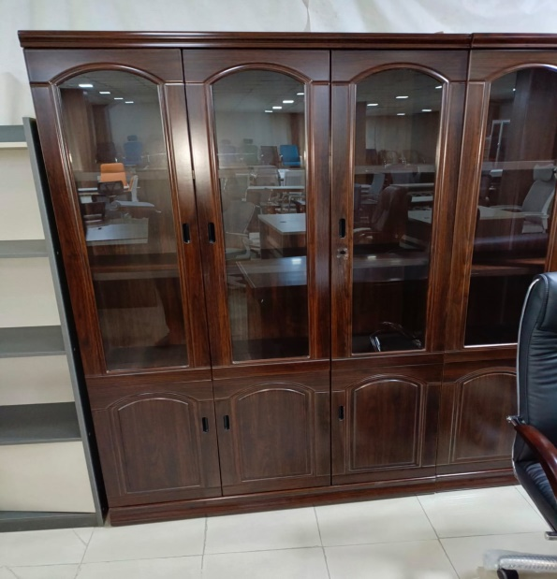

      - Committee Room Table with 12 Chairs (Color: Green)
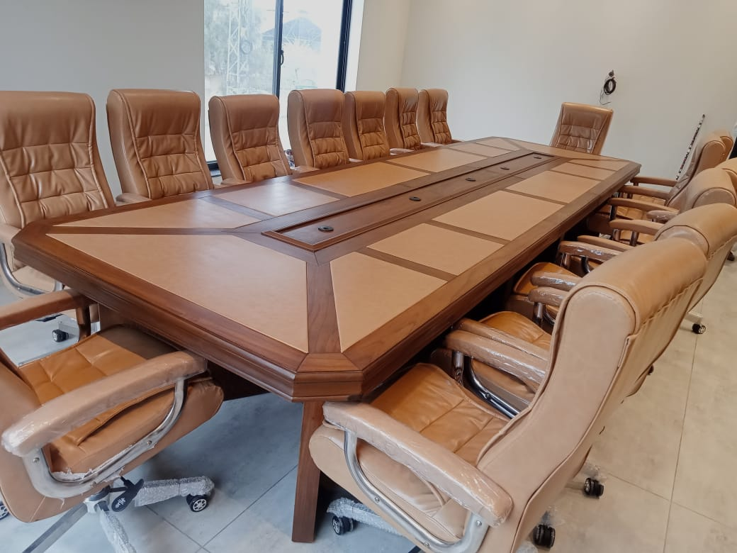

      - Sofa Set (Color: Green)
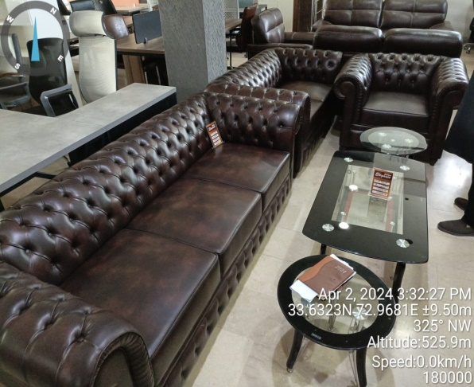

      - Executive Table and Chair
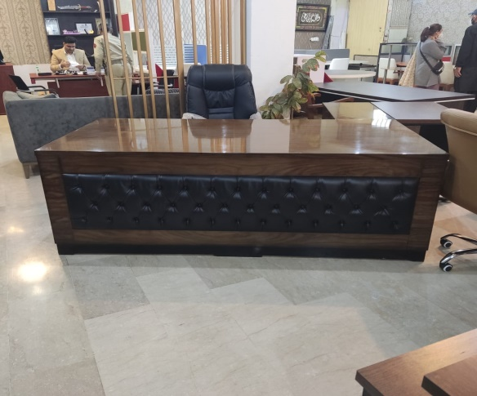

      - Visitor Chairs
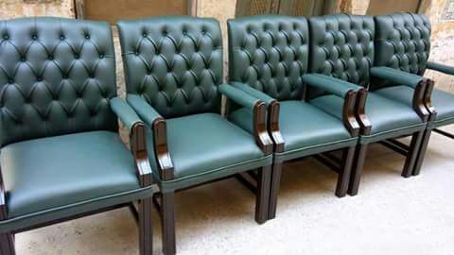

      - Chair Table and Side Rack
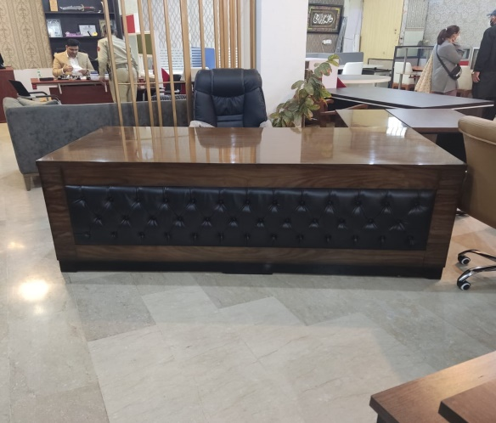

For the avoidance of doubt, a sanctioned party’s ineligibility to be awarded a contract shall include, without limitation, (i) applying for pre-qualification, expressing interest in a consultancy, and bidding, either directly or as a nominated sub-contractor, nominated consultant, nominated manufacturer or supplier, or nominated service provider, in respect of such contract, and (ii) entering into an addendum or amendment introducing a material modification to any existing contract.
A nominated sub-contractor, nominated consultant, nominated manufacturer or supplier, or nominated service provider (different names are used depending on the particular bidding document) is one which has been: (i) included by the bidder in its pre-qualification application or bid because it brings specific and critical experience and know-how that allow the bidder to meet the qualification requirements for the particular bid; or (ii) appointed by the Borrower.
Inspections in this context usually are investigative (i.e., forensic) in nature. They involve fact-finding activities undertaken by the Bank or persons appointed by the Bank to address specific matters related to investigations/audits, such as evaluating the veracity of an allegation of possible Fraud and Corruption, through the appropriate mechanisms. Such activity includes but is not limited to: accessing and examining a firm's or individual's financial records and information, and making copies thereof as relevant; accessing and examining any other documents, data and information (whether in hard copy or electronic format) deemed relevant for the investigation/audit, and making copies thereof as relevant; interviewing staff and other relevant individuals; performing physical inspections and site visits; and obtaining third party verification of information.

